Lab 11 – VHDL

Name: Nhut Quang Tran

Group: NTIVIS14

TURKU UNIVERSITY OF APPLIED SCIENCES

**Exercise 1: Make a VHDL model of an arithmetic logic unit 74xx181. It is enough, if you include the operations mentioned in figure 7-18 b).**

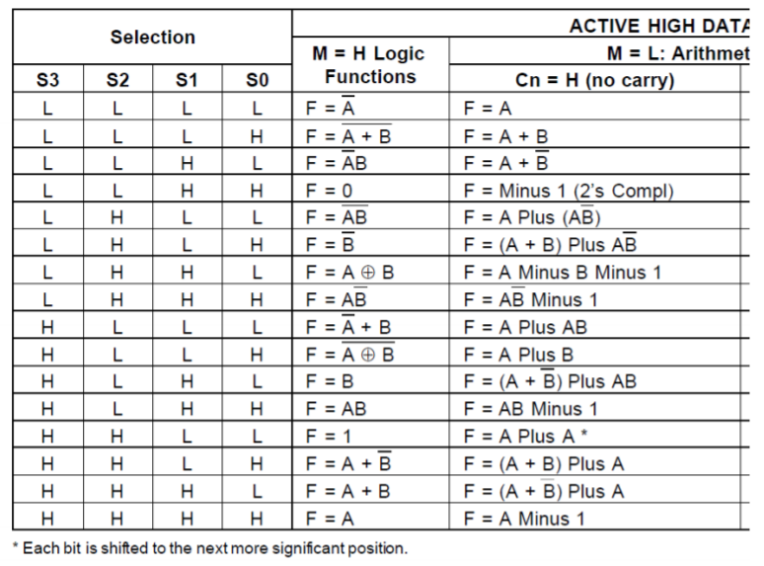**The table:**

**The code:**

|  |
| --- |
| LIBRARY ieee ;  USE ieee.std_logic_1164.all ;  use ieee.numeric_std.all;  use IEEE.std_logic_unsigned.all;  ENTITY Lab11 IS  PORT (A, B, S: IN STD_LOGIC_VECTOR (3 DOWNTO 0) ;  M,CLR: IN STD_LOGIC;  F: OUT STD_LOGIC_VECTOR (3 DOWNTO 0));  END Lab11;  ARCHITECTURE Arithmetic OF Lab11 IS  signal z: std_logic_vector(3 DOWNTO 0) := "0000";  BEGIN  opera_proc: process(M, A, B, S)  begin  if(CLR = '1') then  F <= "0000";  end if;  case M is  when '1' => -- items regarding state ST0    case S is  when "0000" => F <= not A;  when "0001" => F <= not (A or B);  when "0010" => F <= (not A) and B;  when "0011" => F <= "0000";  when "0100" => F <= not (A and B);  when "0101" => F <= not B;  when "0110" => F <= A xor B;  when "0111" => F <= A and (not B);  when "1000" => F <= (not A) or B;  when "1001" => F <= not (A xor B);  when "1010" => F <= B;  when "1011" => F <= A and B;  when "1100" => F <= "0001";  when "1101" => F <= A or (not B);  when "1110" => F <= A or B;  when "1111" => F <= A;    when others => F <= "0000";  end case;  when '0' => -- items regarding state ST1    case S is  when "0000" => F <= A;  when "0001" => F <= A or B;  when "0010" => F <= A or (not B);  when "0011" => F <= std_logic_vector(unsigned((not z) + 1)) - 1 ; --F output = 0000 (2's complement) - 1  when "0100" => F <= A + (A and (not B));  when "0101" => F <= (A or B) + (A and (not B));  when "0110" => F <= (A - B) - 1;  when "0111" => F <= (A and (not B)) - 1;  when "1000" => F <= A + (A and B);  when "1001" => F <= A + B;  when "1010" => F <= (A or (not B)) + (A and B);  when "1011" => F <= (A and B) - 1;  when "1100" => F <= A + (std_logic_vector(unsigned(A) sll 1));  when "1101" => F <= (A or B) + A;  when "1110" => F <= (A or not(B)) + A;  when "1111" => F <= A - 1;    when others => F <= "0000";  end case;  when others => -- the catch-all condition  F <= "0000";  end case;  end process opera_proc;  end Arithmetic; |

**The simulating picture:**

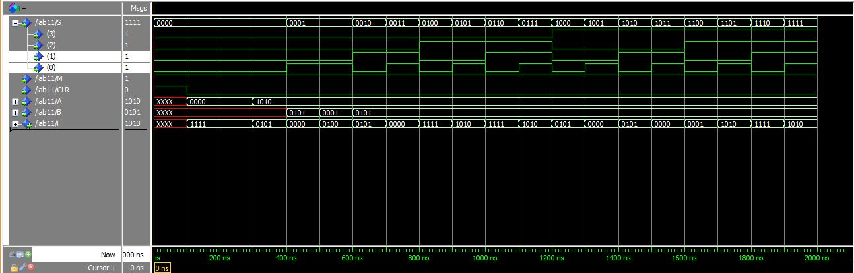

Figure 1.Logic Functions

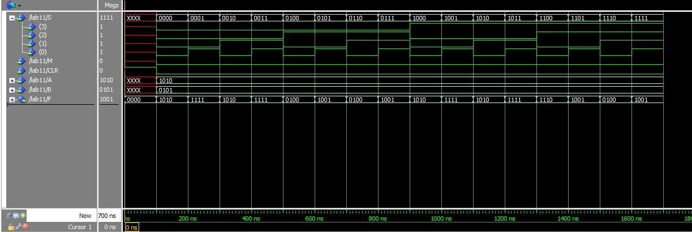

Figure 2. Arithmetic Functions